UNIVERSITY ADMIT ELIGIBILITY PREDICTOR ASSIGNMENT - 1

|  |  |
| --- | --- |
| Date | 13th September 2022 |
| Team ID | PNT2022TMID27839 |
| Student Name | Akash S(311519104007) |
| Domain Name | Education |
| Project Name | University Admit Eligibility Predictor |
| Maximum Marks | 2 Marks |

1.)SPLIT THE STRING

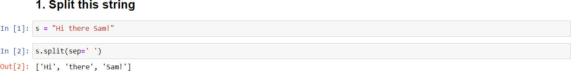

2.)USE .format() TO PRINT THE FOLLOWING STRING

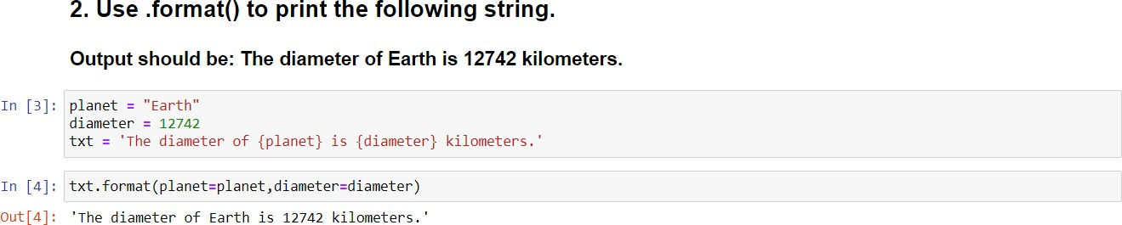

3.)IN THE NEST DICTIONARY GRAB THE WORD “HELLO”

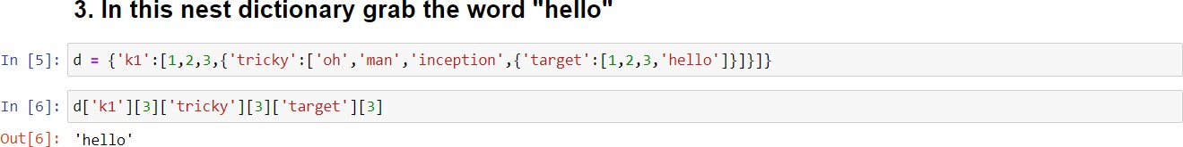

4.) NUMPY

1.) CREATE AN ARRAY OF 10 ZEROS

2.) CREATE AN ARRAY OF 10 FIVES

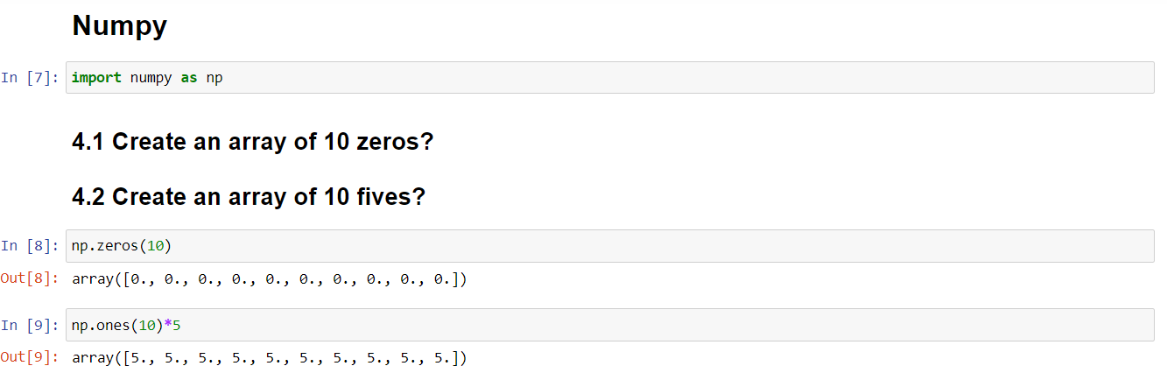

5.)CREATE ARRAY OF ALL THE EVEN INTEGERS FROM 20 to 35



6.)CREATE A 3x3 MATRIX WITH VALUES FROM 0 to 8

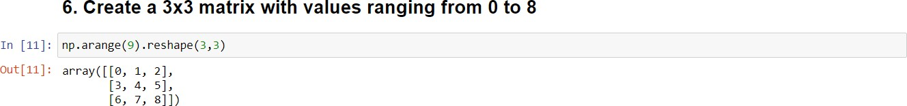

7.)CONCATENATE a AND b

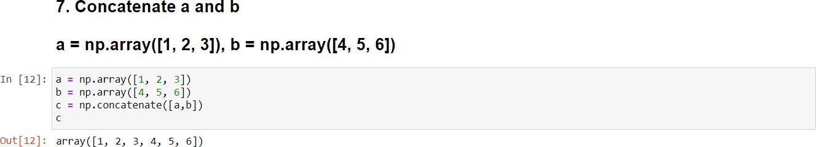

8.) PANDAS

CREATE A DATAFRAME WITH 3 ROWS AND 2 COLUMNS

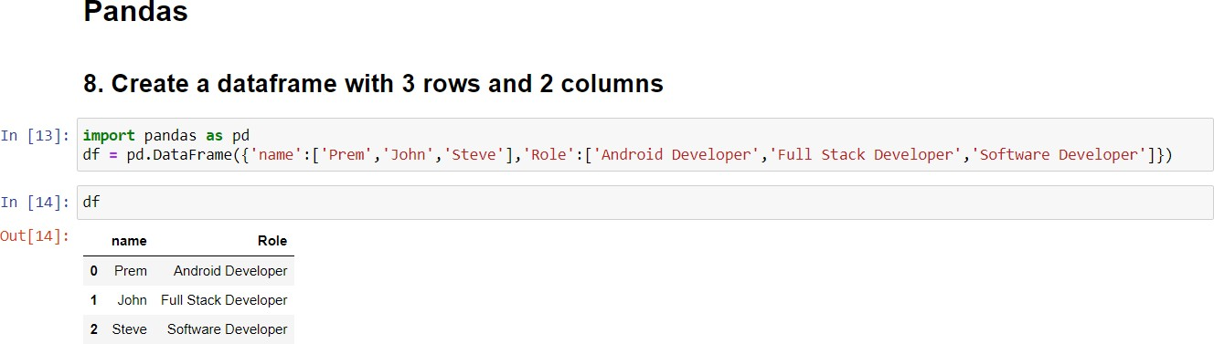

9.) GENERATE THE SERIES OF DATES FROM 1st JAN 2023 TO 10th FEB 2023

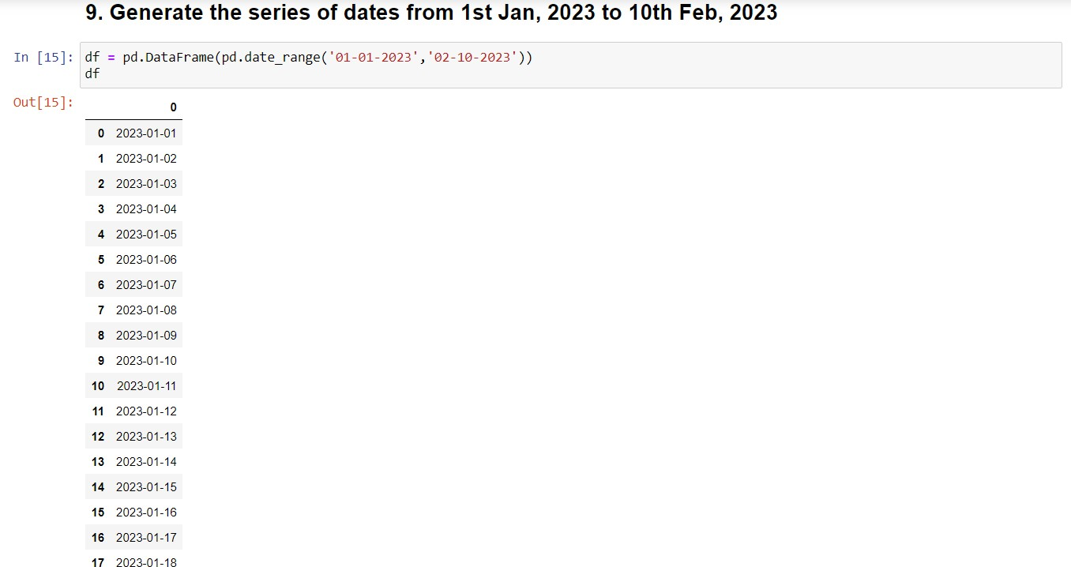

10.) CREATE 2D LIST TO DATAFRAME

